An Introduction to the Serious Violence Duty
for the Community and Voluntary Sector

Report Owner: North Wales Serious Violence Duty Programme Team
- The Serious Violence Duty Introduction

Following public consultation in July 20192, the Government announced that it would bring forward legislation introducing a new Serious Violence Duty (“the Duty”) on a range of specified authorities. This will ensure relevant services work together to share information and allow them to target their interventions, where possible through existing partnership structures, collaborate and plan to prevent and reduce serious violence within their local communities.

The duty has come into effect from 01/03/23 and is a key part of the Government’s programme of work to collaborate and plan to prevent and reduce serious violence: taking a multi-agency approach to understand the causes and consequences of serious violence, focusing on prevention and early intervention, and informed by evidence.

- The ‘Duty’
The Duty covers the requirements set out in Chapter 1 of Part 2 of the PCSC Act. It requires specified authorities for a local government area to work together and plan to prevent and reduce serious violence, including identifying the kinds of serious violence that occur in the area, the causes of that violence (so far as it is possible to do so), and to prepare and implement a strategy for preventing, and reducing serious violence in the area. The Duty also requires the specified authorities to consult educational, prison and youth custody authorities for the area in the preparation of their strategy.

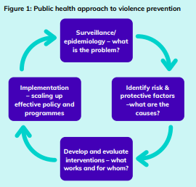
The duty encourages local areas are encouraged to adopt the World Health Organisation’s definition of a public health approach:
- Focussed on a defined population
- With and for communities
- Focussed on generating long term as well as short term solutions
- Based on data and useful information to identify the burden on the population, including any inequalities
- Rooted in evidence of effectiveness to tackle the problem

The core elements of the Duty:
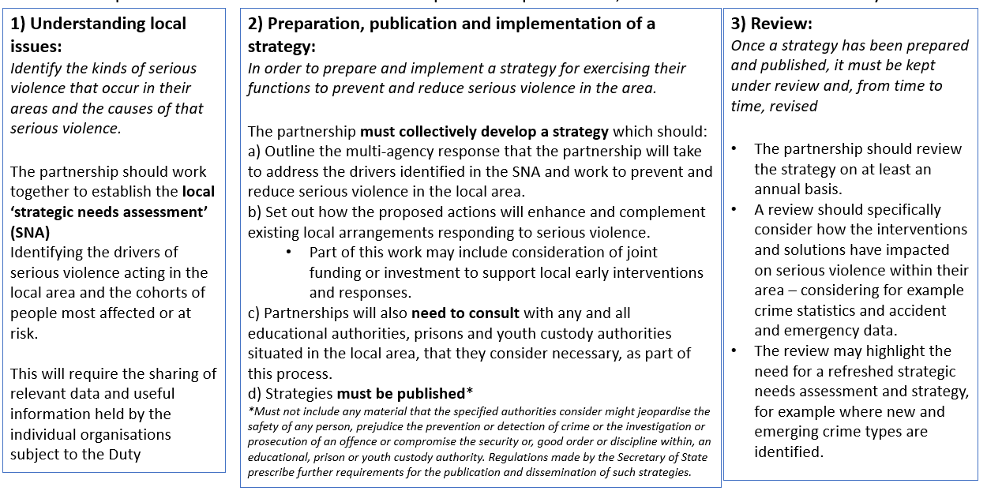

To aid with the implementation and compliance of the duty, the Home Office have granted some funding to North Wales for the period 01/01/2023 – 31/03/2025. There are no further arrangements for funding the continued duty requirements outside of this period.

The Serious Violence Duty Guidance and a useful ‘7-minute briefing’ prepared by the Wales Safer Communities Network can be found following the below links:
Serious Violence Duty - Statutory Guidance (publishing.service.gov.uk)
SVD-7-min_January-2023-2.pdf (safercommunities.wales)

The duty states Specified Authorities are to identify a Partnership Structure which will collaborate and plan to reduce and prevent serious violence in their local area(s) producing a Strategic Needs Assessment, a strategy and evaluating impact all whilst adopting a public health approach. The PCSC Act does not specify the partnership model but states specified authorities should collectively decide on the appropriate partnership in which they will work together to undertake the requirements of the Duty.

The Specified Authorities stated within the duty are Police, Fire and Rescue, local health board, Local Authorities, Youth Offending Teams, and Probation.

It should also be noted that the duty states:
- Under the legislation educational, prison and/or youth custody authorities are able to co-operate with the specified authorities as necessary and are known as the relevant authorities. Relevant authorities must collaborate with specified authorities to prevent and reduce serious violence in the local area if their involvement is requested.
- CSPs are subject to both the new Crime and Disorder Act requirements and the Duty, this will enable them to escalate local serious violence issues to a higher strategic level. It is fundamental that CSPs are aligned and involved in the partnership.
- The duty guidance recognises the value of third sector (Community and Voluntary Sector) support in delivering a Serious Violence Duty that properly reflects local issues and should be properly considered.
- The duty also recognises the value other relevant Wales wide contribution and support such as Welsh Gov, The Wales Violence Prevention Unit, Public Health Wales, The Wales Safer Communities Network etc.
- Other relevant local and regional strategies and action plans on the strategic context to prevent serious violence should be considered by specified authorities/the partnership when delivering their responsibilities under the duty.

Our Local Partnership Structure

The North Wales Office of the Police and Crime Commissioner are the grant holder and take on the lead convenor role, supporting the North Wales d5evelopment and implementation of the Serious Violence Duty across the North Wales Policing area.

A small programme team is in place consisting of a mix of Home Office funding and partnership resources. This team will be responsible for all Home Office grant requirements, leading and driving delivery and compliance of the duty, raising awareness and building a mature partnership.

The operational activity is driven through the ‘Serious Violence Duty Task and Finish Group’, the core membership includes specified authorities, relevant authorities, and others. This is currently growing in membership to strengthen the partnership and we are extremely keen to strengthen the Community and Voluntary Sector/third sector for a true co-produced, holistic, informed public health approach. The group meet once a month.
- The partnership are focussed on the public health whole-system multi-agency approach to serious violence prevention known as the ‘5Cs’ – collaboration, co-production, cooperation in data and intelligence sharing, counter-narrative, community consensus.
The responsible strategic partnership board for delivering the Duty is the North Wales Safer Communities Board. This board holds responsibility for the serious violence portfolio along with Serious and Organised Crime and Community Safety. All specified authorities participate in this board which meets on a quarterly basis. The operational group are accountable to this board and provide updates on activity, progress and any issues and risks for escalation should they arise.

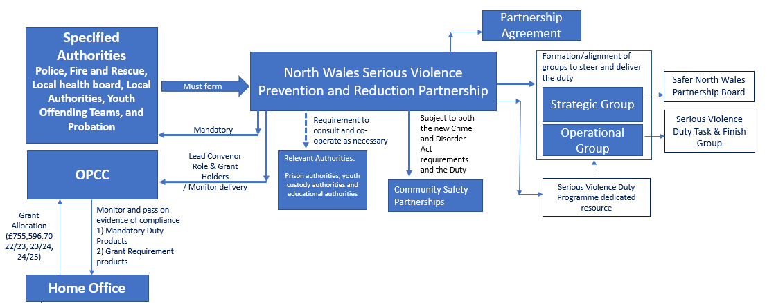

Alignment to other relevant cross cutting boards – This will be done via communication under the existing structure set out below:

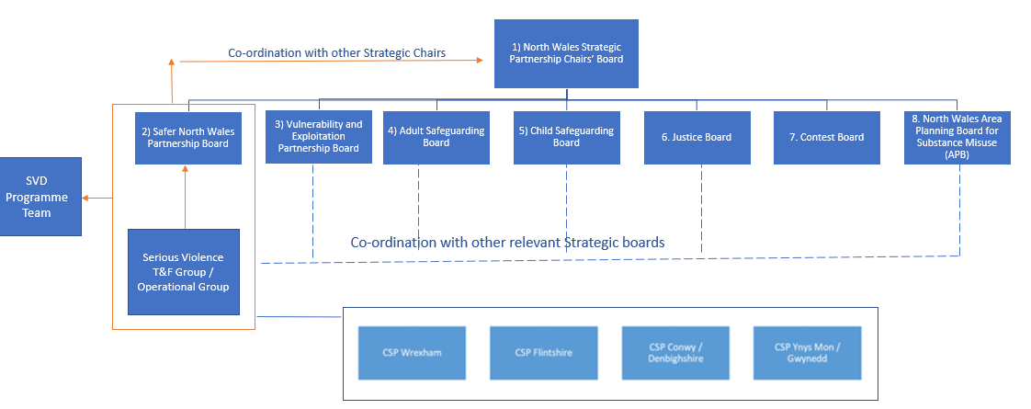

What the duty says in relation to the Community and Voluntary Sector (Third Sector)

- The Third sector contributes widely to supporting people in Wales. As recognised in the general guidance, their support in delivering a Serious Violence Duty that properly reflects local issues should be properly considered.

- Community and Voluntary Sector (Third Sector) in Wales are a key and important partner across partnerships, including Regional Partnership Boards, Regional Safeguarding Boards and Public Service Boards. Attendance is, as an equal partner, acknowledging the important trusted and independent role that the organisations play in local communities and in providing links with all sectors of local communities. Utilising the skills of the sector is an important element of delivering Welsh legislation. This is supported through Third Sector Support Wales, a partnership of the local Community Voluntary Councils across Wales and the national body Wales Council for Voluntary Action. The collaboration, integration and engagement with this sector will be a key element for delivery of the Serious Violence Duty (for example providing input into the analysis of the problems associated with serious violence in the local area and solutions for tackling them)

- localities will be required to embed the voices and lived experiences of the communities they serve in their Serious Violence Duty-related activity. Both the SNA and local strategy should reflect the voices and lived experiences of the communities they intend to support. Not constrained by organisational or professional boundaries; in order to successfully deliver the Serious Violence Duty, duty holders are required to work across professional and organisational boundaries in order to deliver a truly multi-agency approach.

What the duty says in relation to engaging with children and young people, victims, survivors, and perpetrators of crime.

- Engagement and involvement with all parts of the population across Wales is a key requirement of existing legislation: the SS&WB Act, WFG Act and VAWDASV Act to name a few. We expect the existing arrangements to be expanded to include all groups who are currently not engaged with, or to adapt the questions and data gathered to include an element of serious violence and its impact on all parts of the community. This should include children and young people, adults including older people, those from marginalised groups, victims and survivors in the case of violence against women domestic abuse and sexual violence, as well as perpetrators. This can and should include the collection of data sets and information from community and voluntary groups who are already working in these fields and are engaging with communities in ways that statutory bodies may not be able to.

- A National Survivor Engagement Framework will be developed in Wales as part of the National VAWDASV Strategy and Blueprint. This will combine multiple ways in which survivors can influence work in Wales and provide a vehicle for survivors to advocate for themselves to educate their peers, communities, colleagues and wider stakeholders. The insight provided by the Framework will be an important source of insight for authorities as they deliver the Serious Violence Duty in Wales.

Co-production is a very important element of our partnership public health approach and has an integral function within our partnership collaboratively informing:
- Decision making
- The local evidence base - through data sharing & Strategic Needs Assessment
- Delivery of the Response Strategy
- Review & evaluation

